**Image 1:**

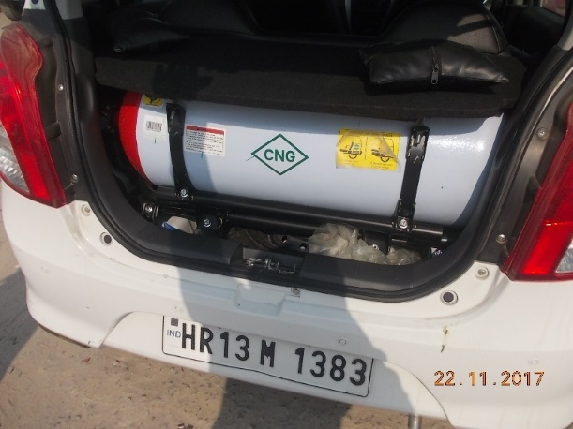

**Results:**

No text extracted from the image.

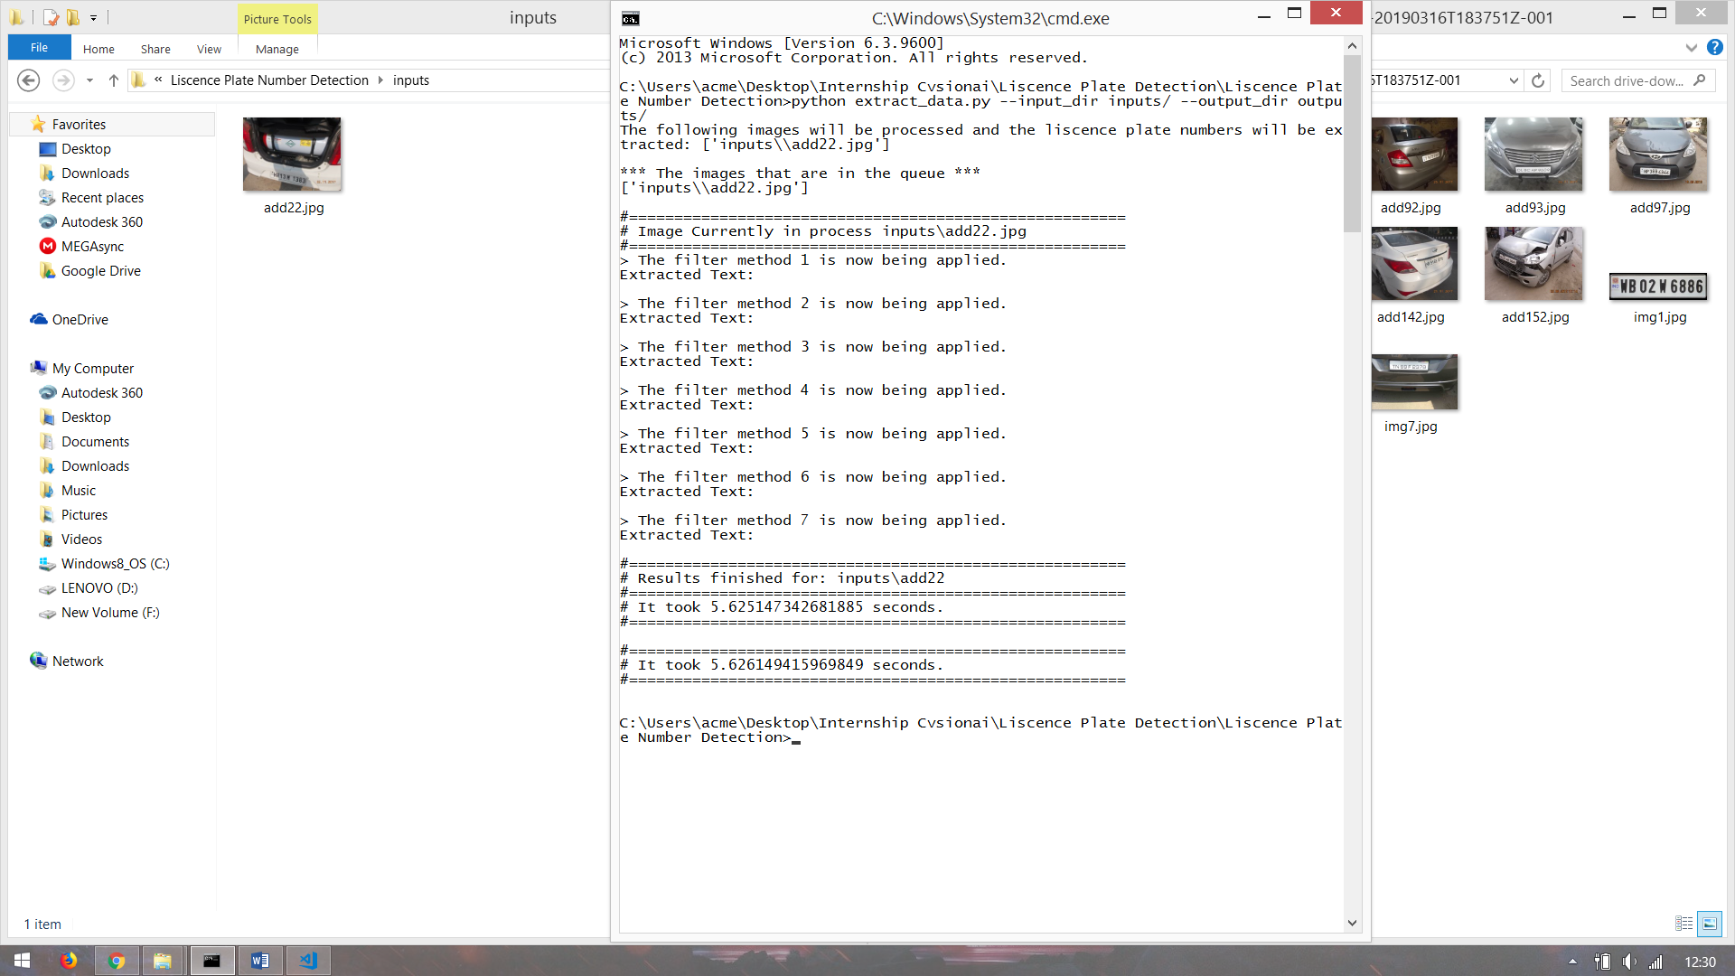

**Image 2:**

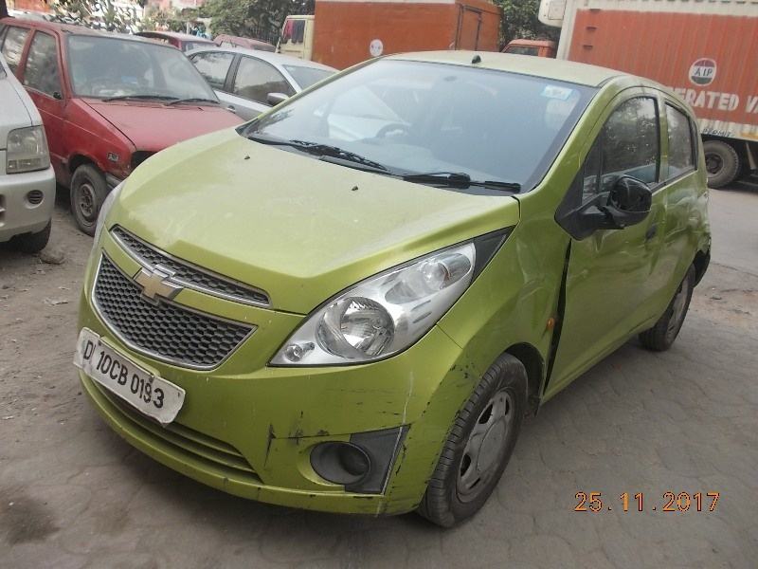

**Results:**

Error in detecting Number Plate. The module is not able to detect the rectangle of the number plate.

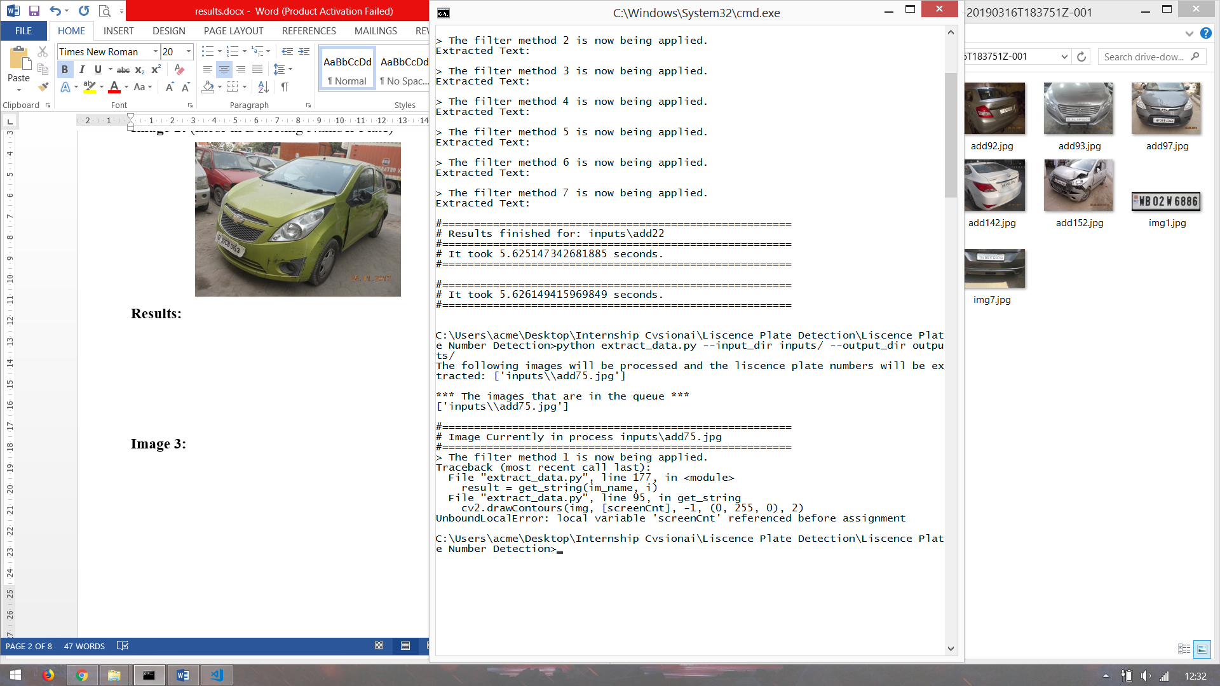

**Image 3:**

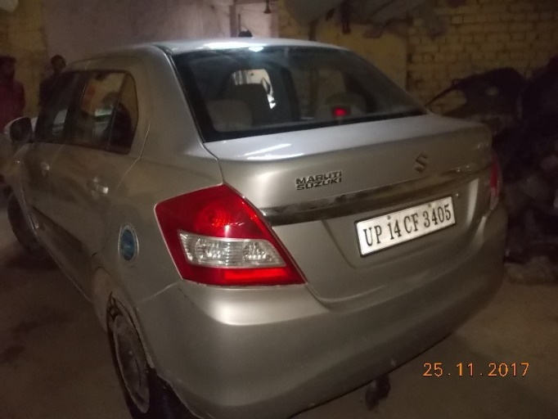

**Results:**

Number is extracted from the image but still need some processing which can be done by using REGEX.

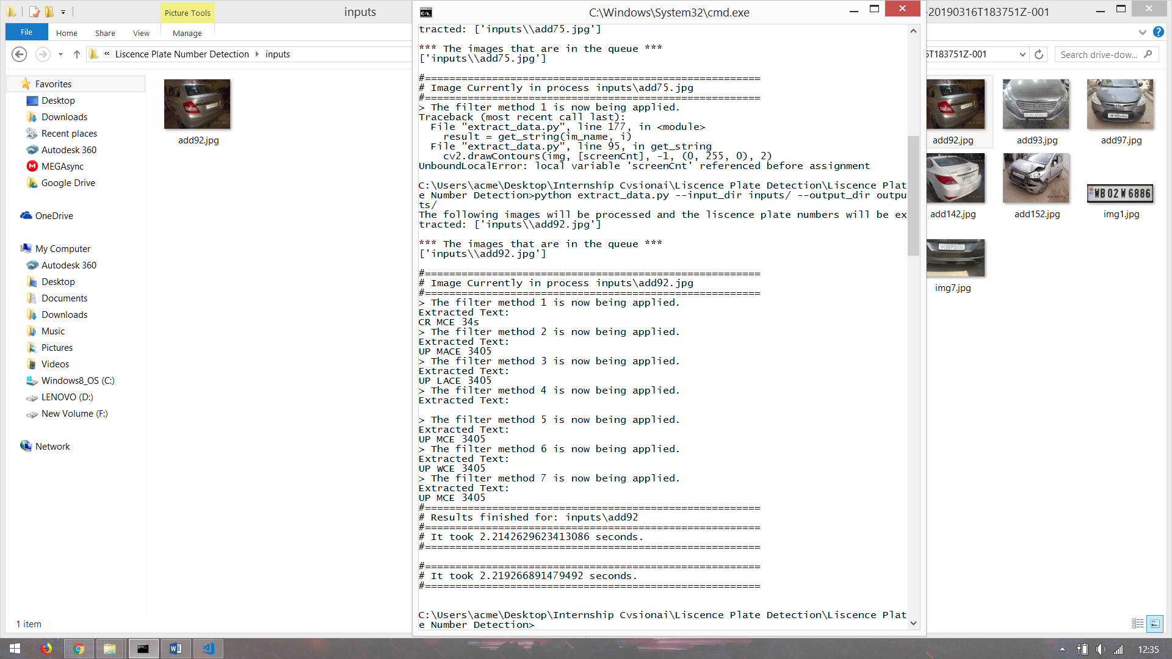

**Image 4:**

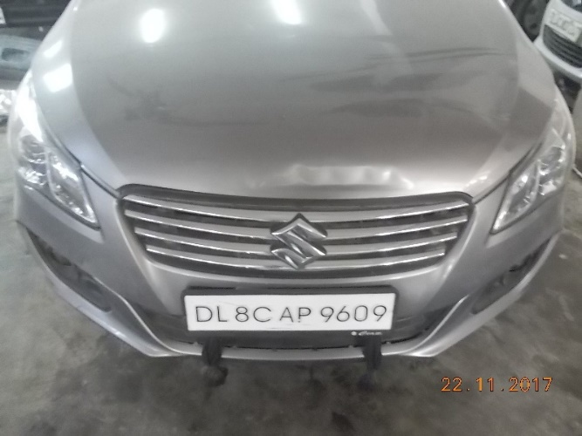

**Results:**

Number is succesfully extracted from the image.

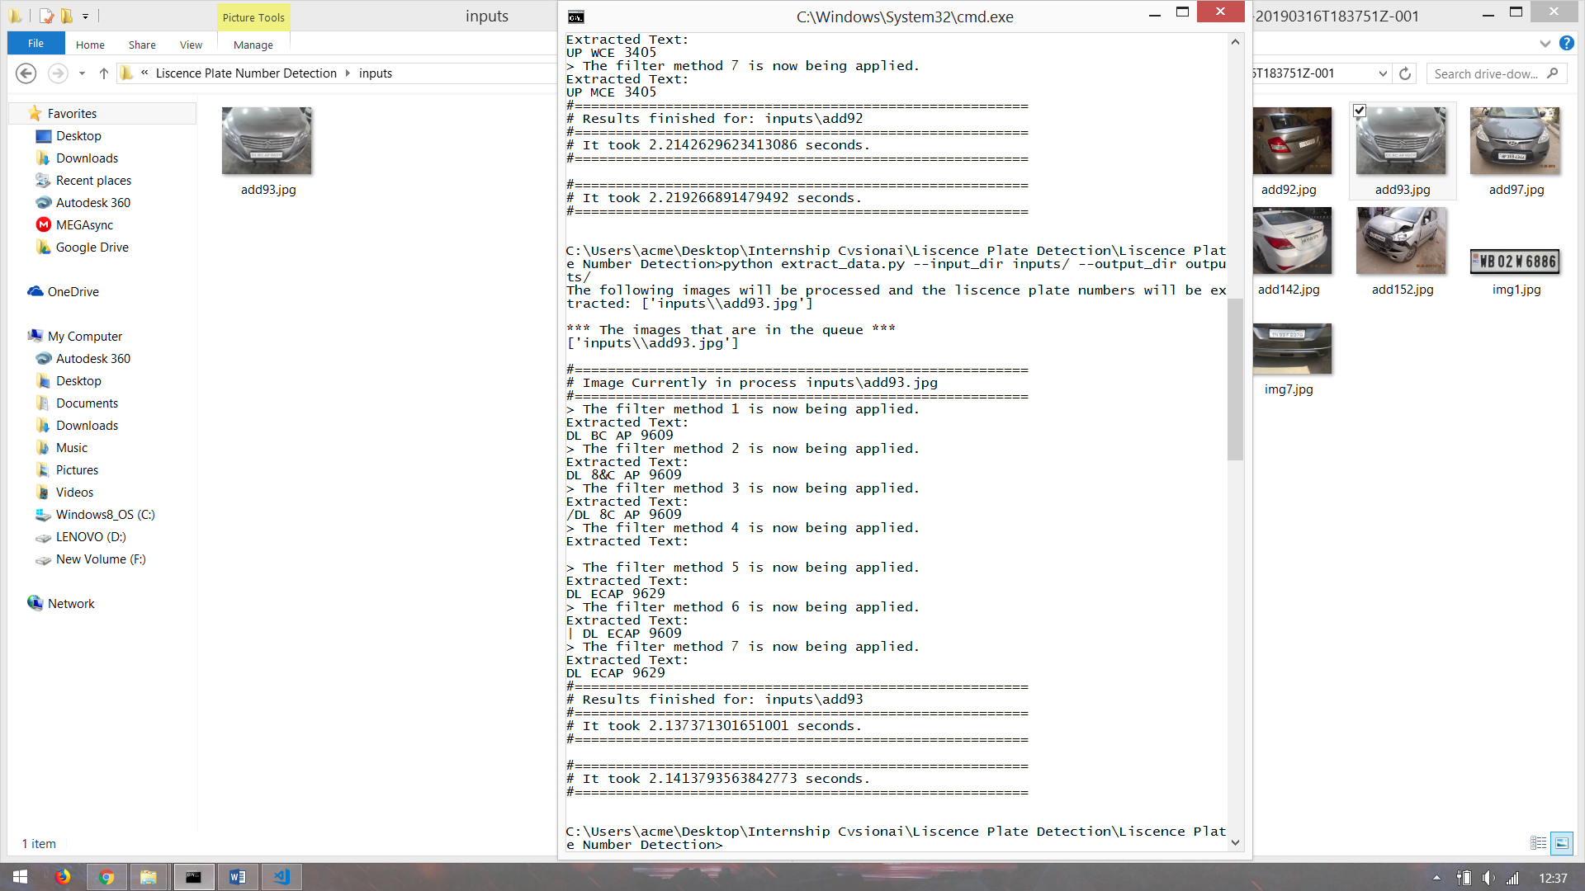

**Image 5:**

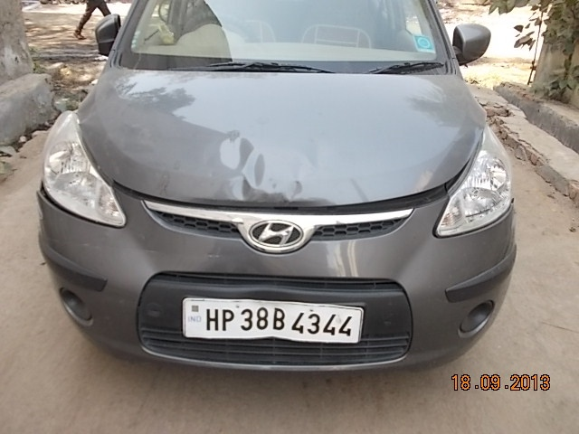

**Results:**

Error in detecting Number Plate. The module is not able to detect the rectangle of the number plate.

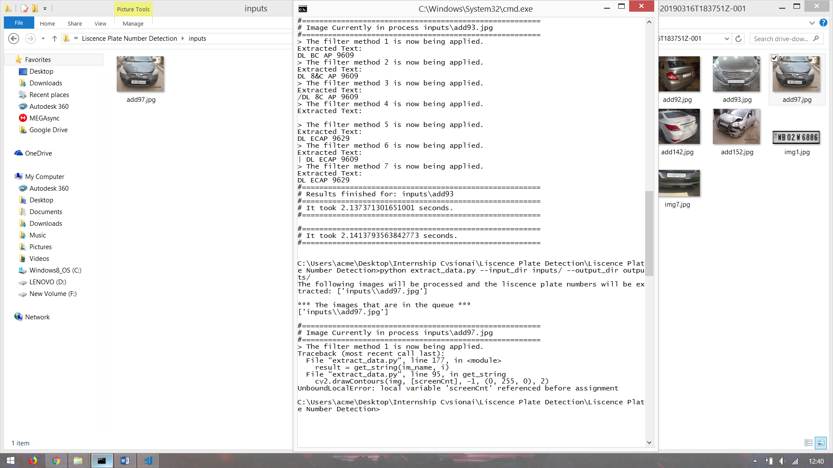

**Image 6:**

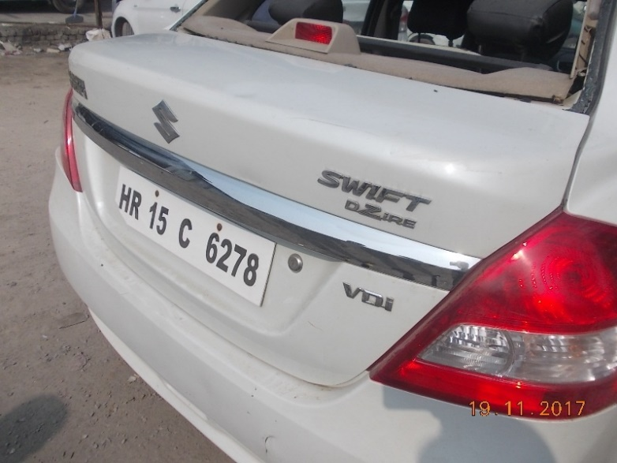

**Results:**

No text extracted from the image.

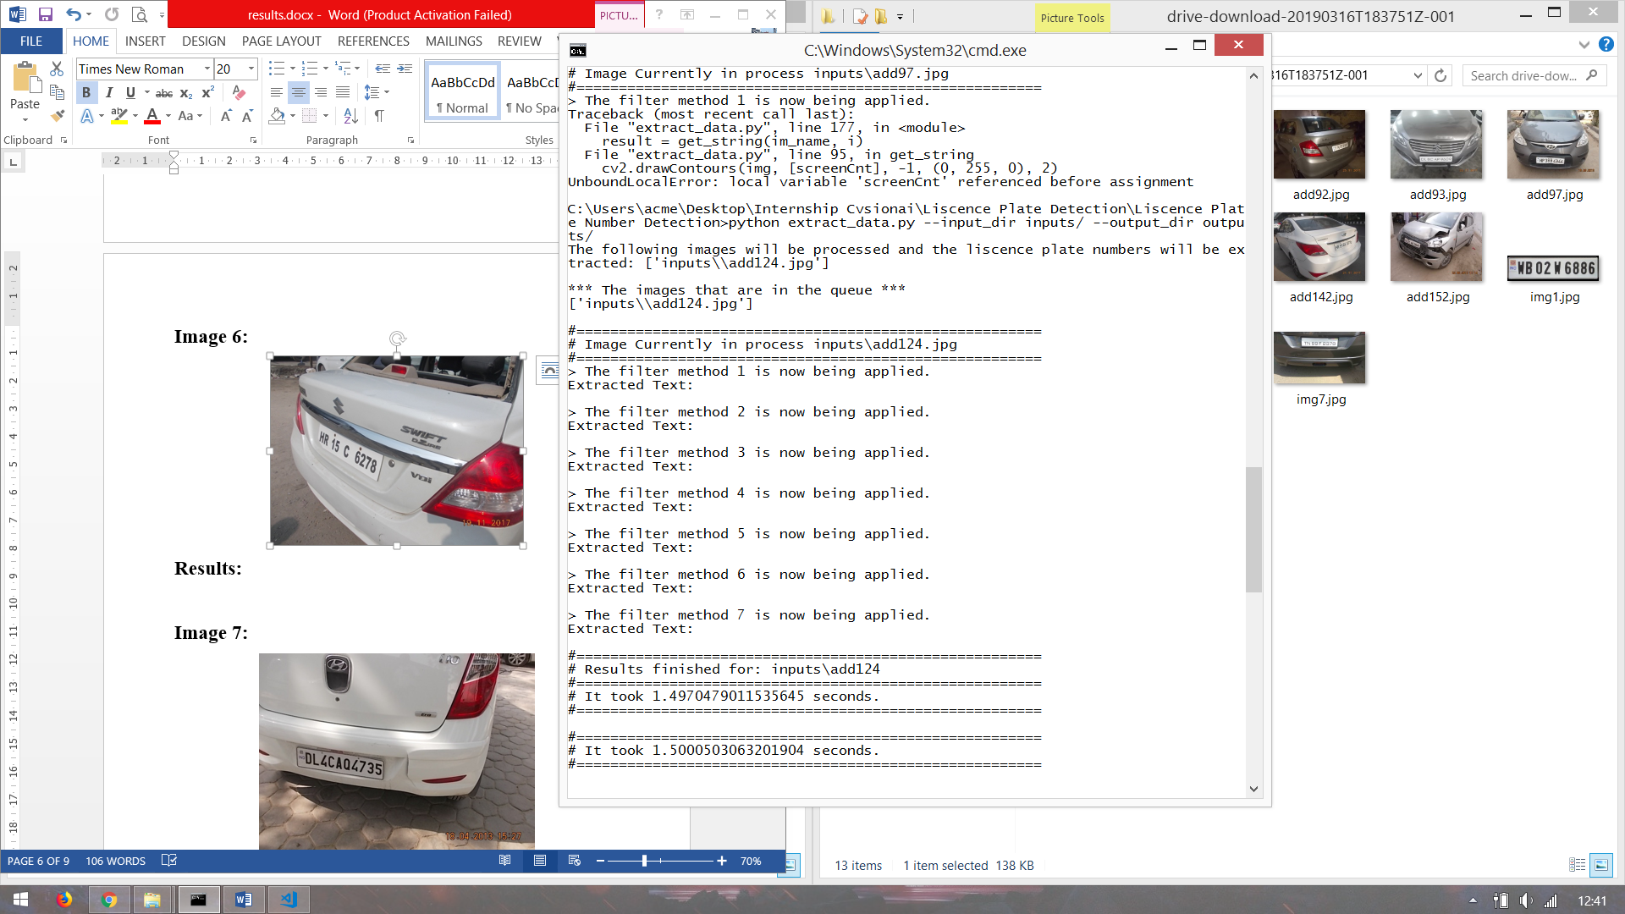

**Image 7:**

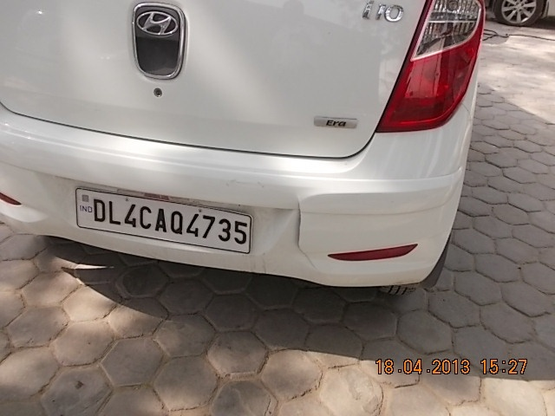

**Results:**

Number is succesfully extracted from the image.

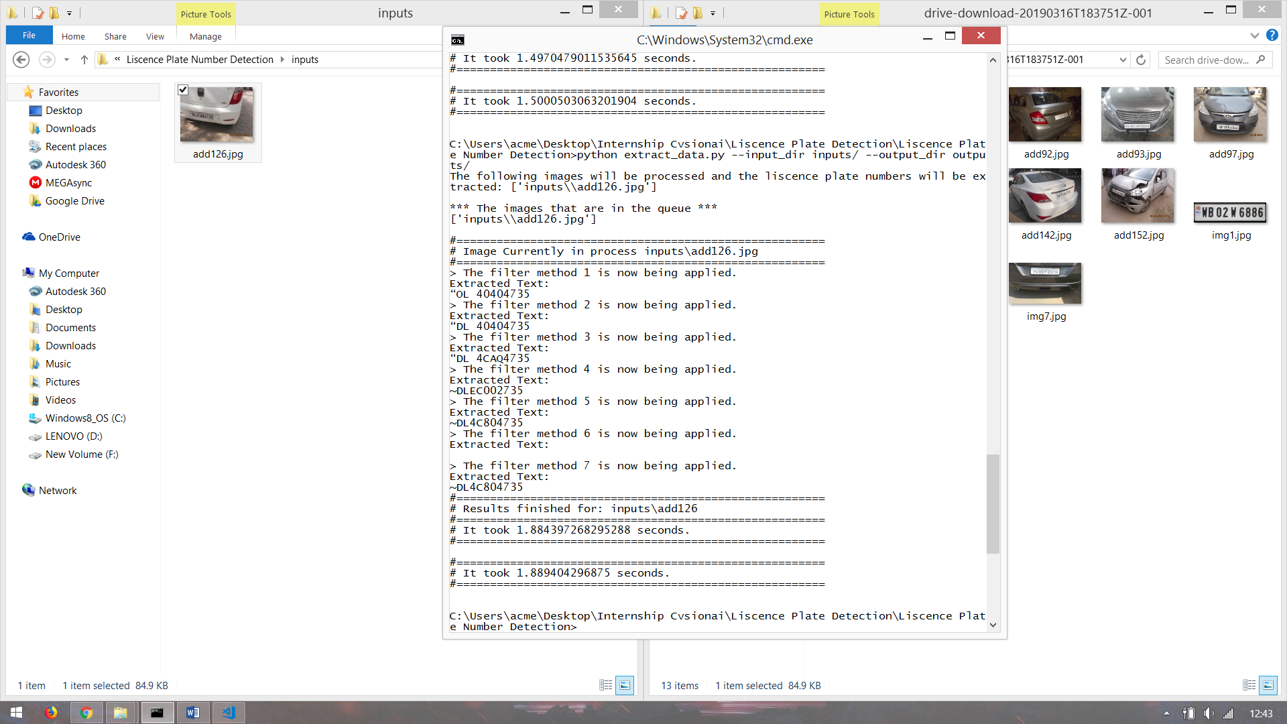

**Image 8:**

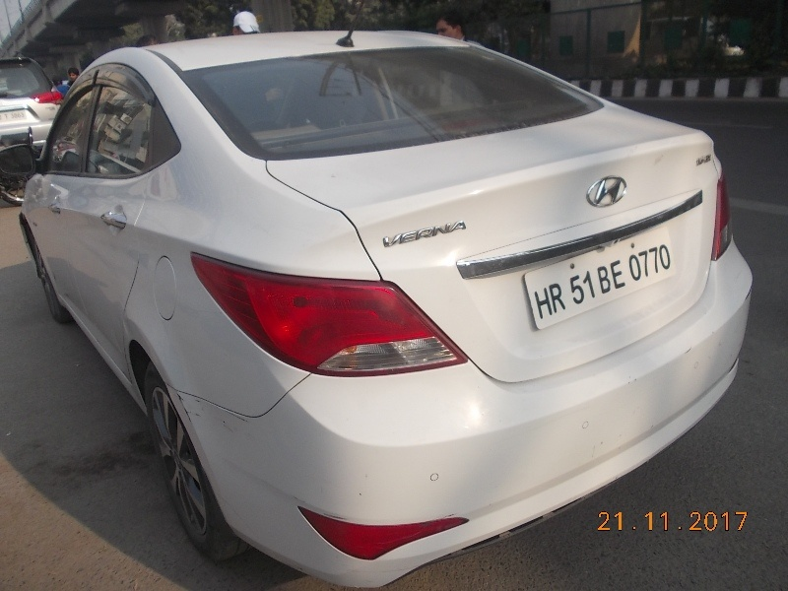

**Results:**

No text extracted from the image.

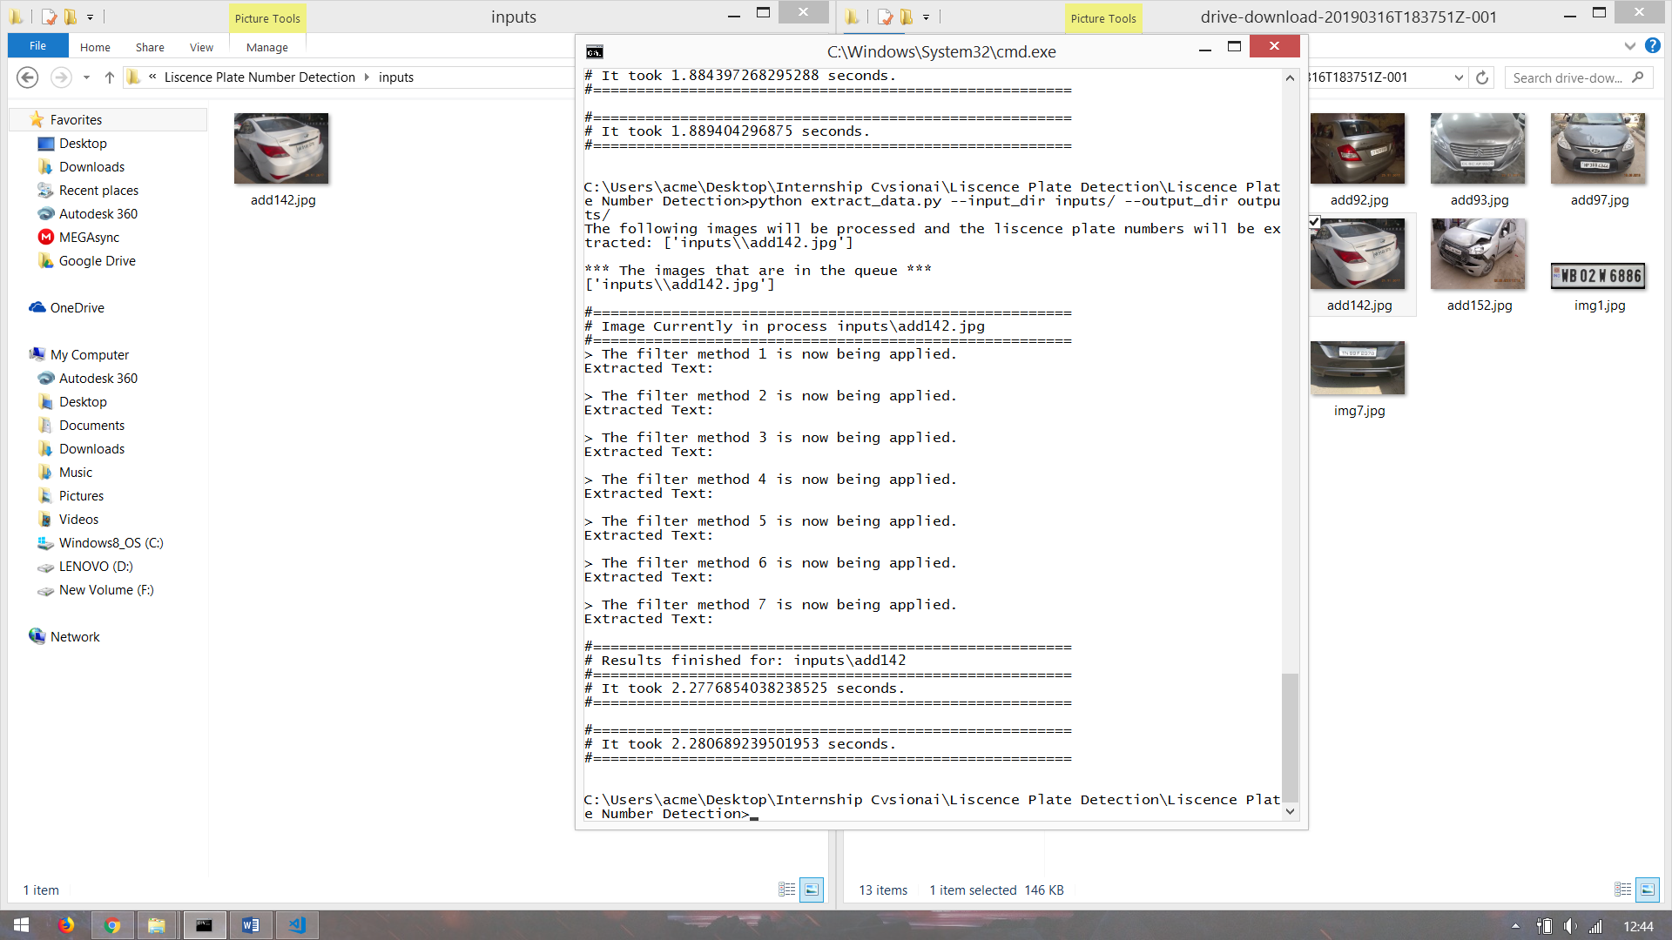

**Image 9:**

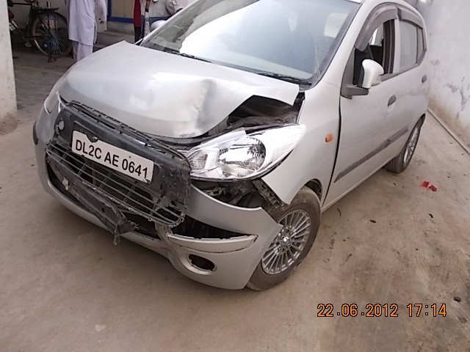

**Results:**

Error in detecting Number Plate. The module is not able to detect the rectangle of the number plate.

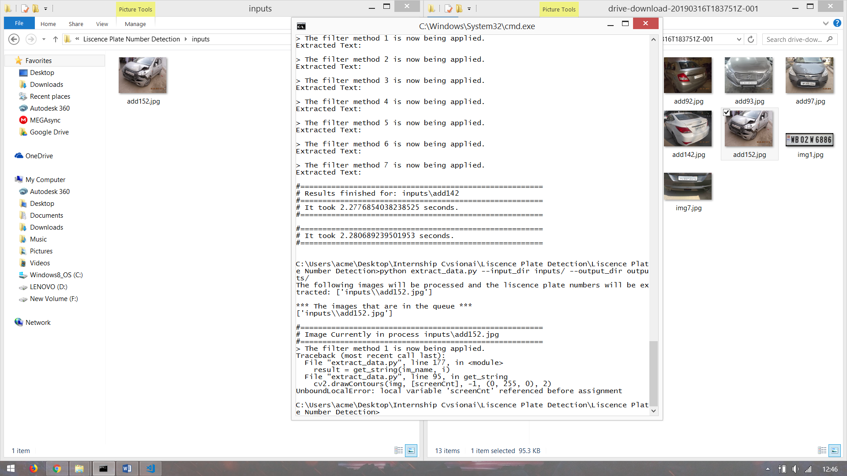

**Image 10:**

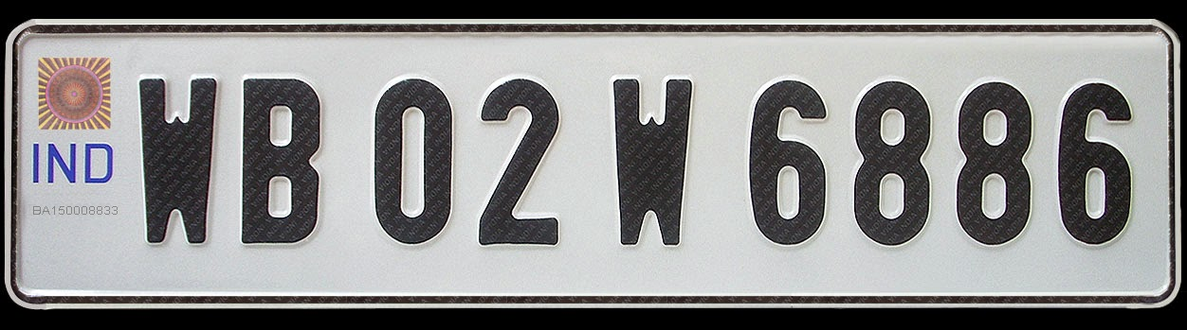

**Results:**

Number is partially extracted from the image.

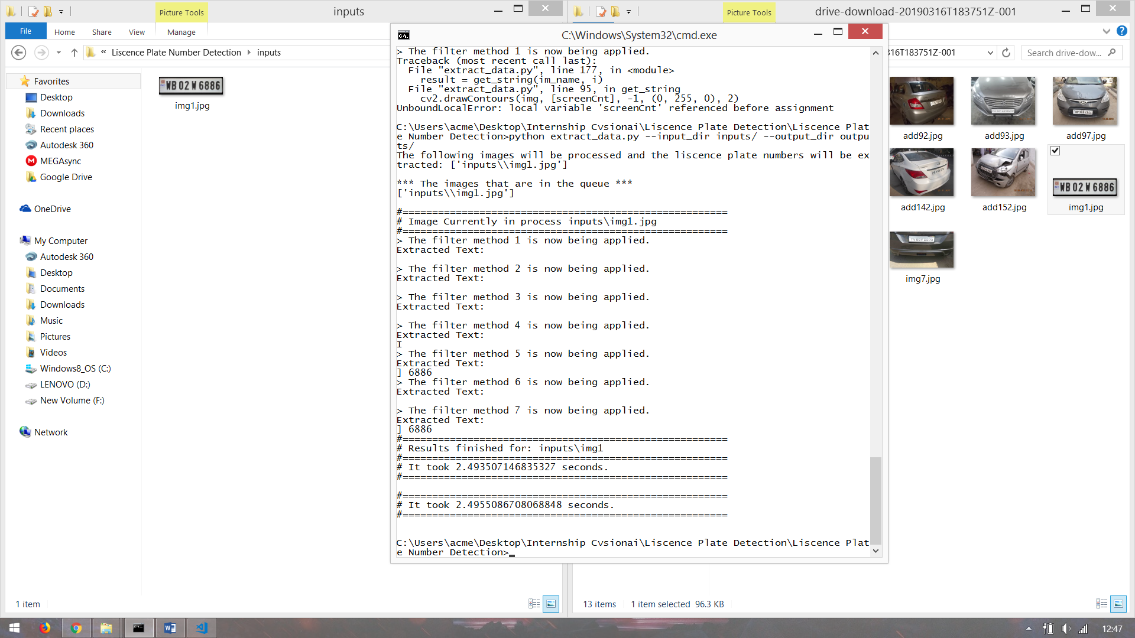

**Image 11:**

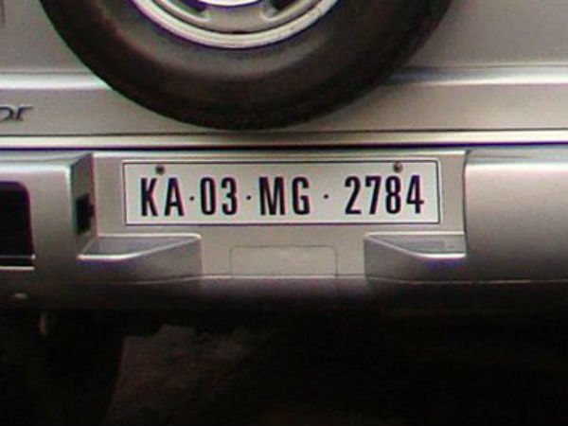

**Results:**

Error in detecting Number Plate. The module is not able to detect the rectangle of the number plate.

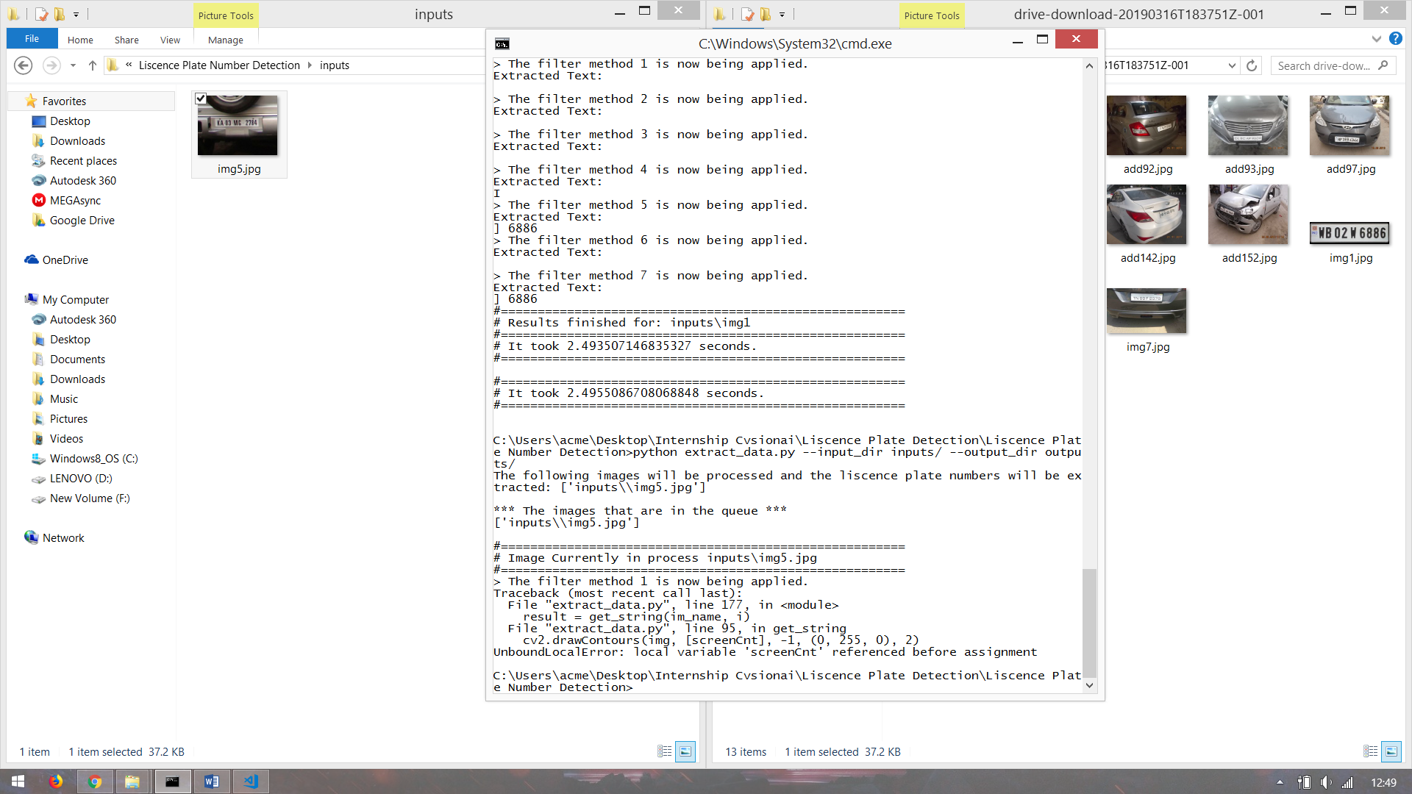

**Image 12:**

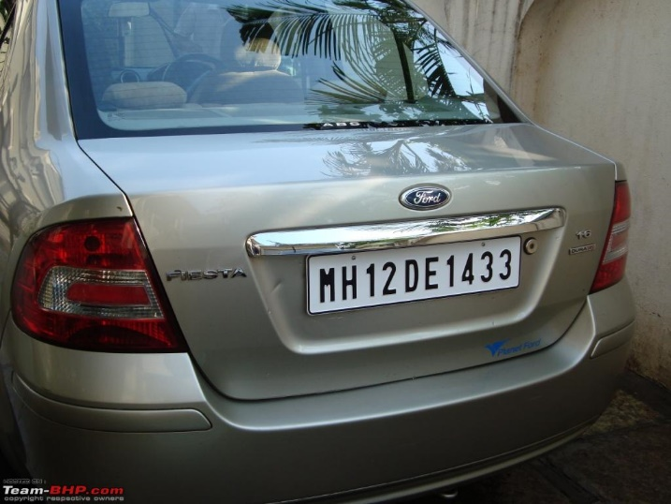

**Results:**

Number is extracted from the image.

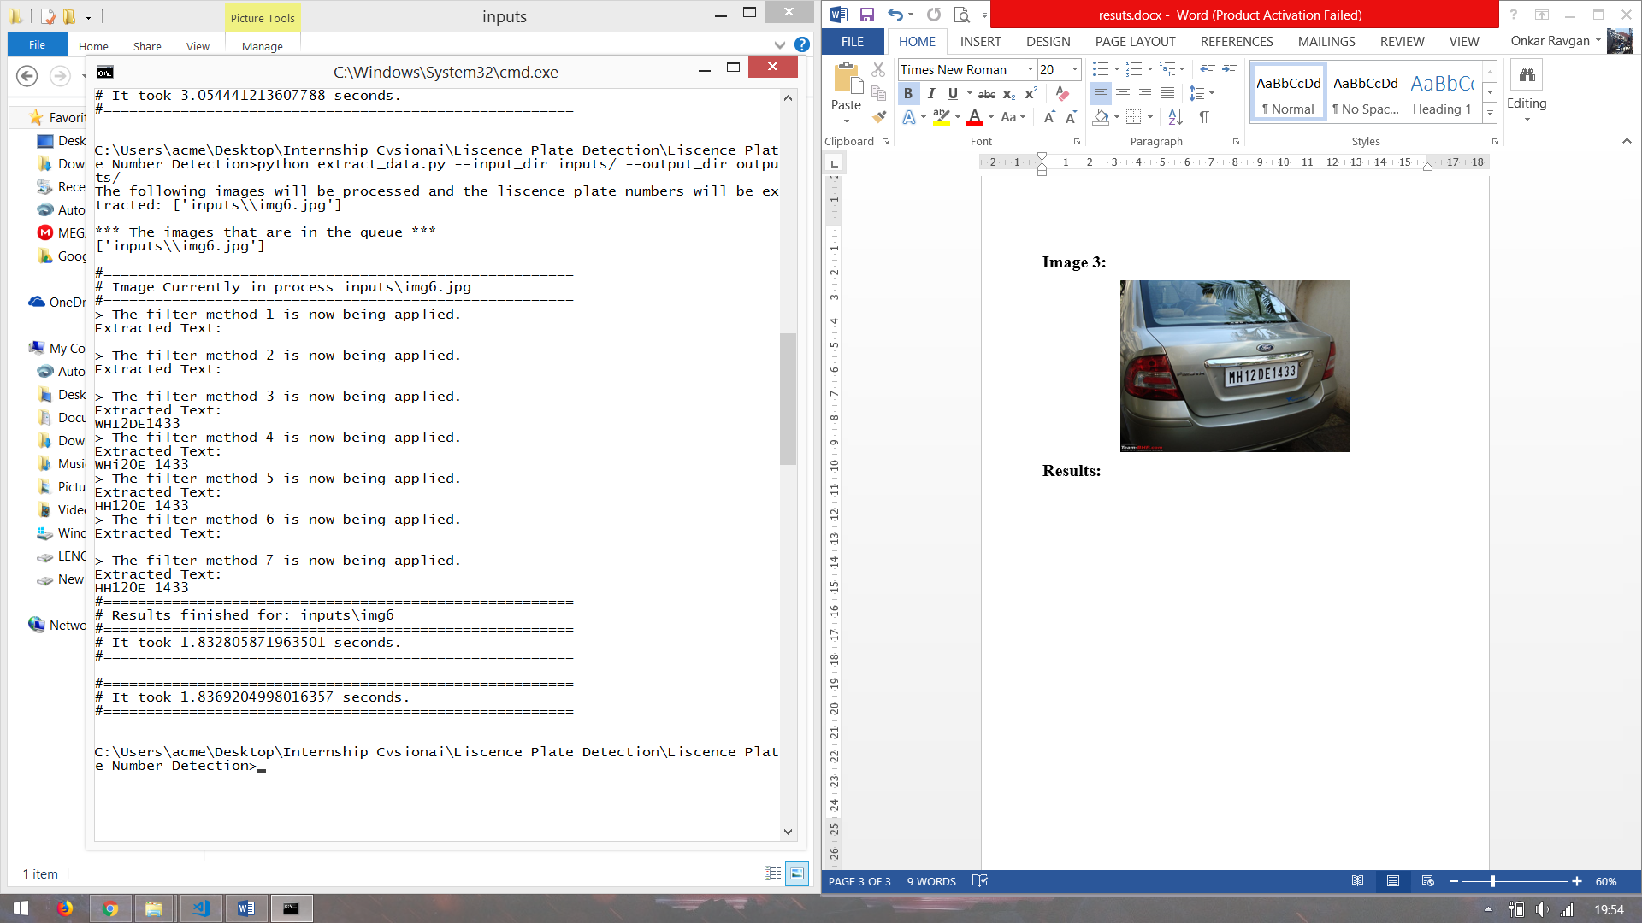

**Image 13:**

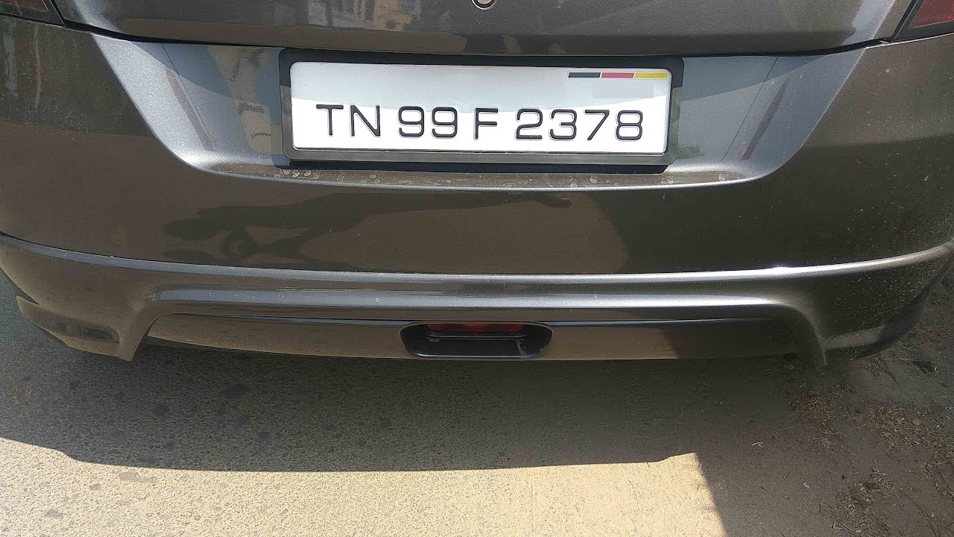

**Results:**

Number is extracted from the image but still need some processing which can be done by using REGEX.

